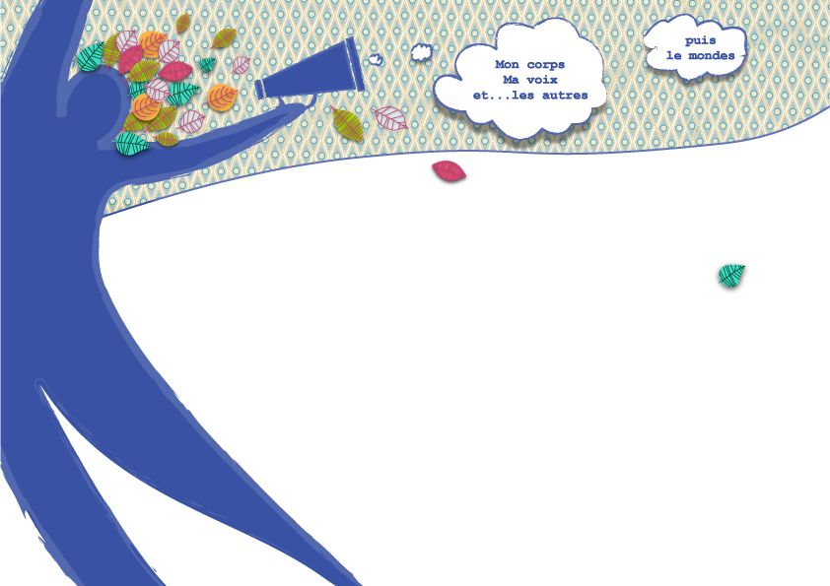
Play
COOP&

COOP & PLAY
EUROPEAN TRAINING COURSE
CALL FOR PARTICIPANTS
and GUIDELINES

14-23 September 2016
Laguépie, Midi-Pyrénées, France

PARTNERS : ATPDSC (Romania), Inex ( Czech Republic), Egyesek (Hungary), Elix (Greece), Genctur (Turkey), InformaGiovani (Italy), Jaunatne Smaidam (Latvia), Proyecto Kieu (Spain).
TARGET GROUP : 24 adult participants with a previous experience in leading or supporting new or existing groups

Application Deadline
15 August 2016
info@informa-giovani.net
WHAT IS COOP & PLAY ?

Coop&Play Training Course intends to gather 24 participants from 8 countries (youth workers, leaders, mentors, team managers, people involved in supporting a group) and provide them with the opportunity of learning and experiencing tangible and playful methodologies for raising individual and collective participation in their projects while working on their professional and personal position.

Together participants will think and learn about team building issues (group dynamic, motivation, inclusion...) through creative tools for expression, debate, analysis, decision making and trust building. They will intensely experience the fun and discovery of playful methods for self-learning processes and reinforcement of soft skills (self confidence, acceptance...). Participants will come up with a tool set easily be implementable with their target groups in their community

METHODS

This training will be based on cooperative and non formal methods asking for everyone's active participation. The participants will also experience a self and collective exploration playful process, thanks to a transversal body approach, based on clown techniques, which they can later develop in their work.
Working methods will aim at developing trust building, inter-knowledge and dialogue, experience sharing and cooperative reflection.

The team of trainers will be made of 4 people : 3 youth workers / trainers in the field of group leading and non formal education, 1 artist specialised in personal development, clown and dance.

PARTICIPANTS

This training is intended for 24 participant from 8 countries more than 18 years old (each country should provide 3 participants) who :
- lead both new and established youth groups, with a previous experience in group leading or support
- have interest for the topic and are ready to actively take part in the whole duration of the training course, with English as working language

PROGRAM
In total there are 8 working days including around 6-8 working hours per day, plus meals and breaks. The Training Course will include free time, that people can use as they want (do sport, reflect on the training, visit around, etc.) Rhythm of the training will be decided with the group, according to the participants needs. One day will be used for a local visit, that participants will set up together.

Make sure you arrive on the 14 of September to start the program together.

If you want to arrive earlier or leave later and you need accommodation contact us before the training, so that we can help you to find a place to stay.

ACCOMMODATION
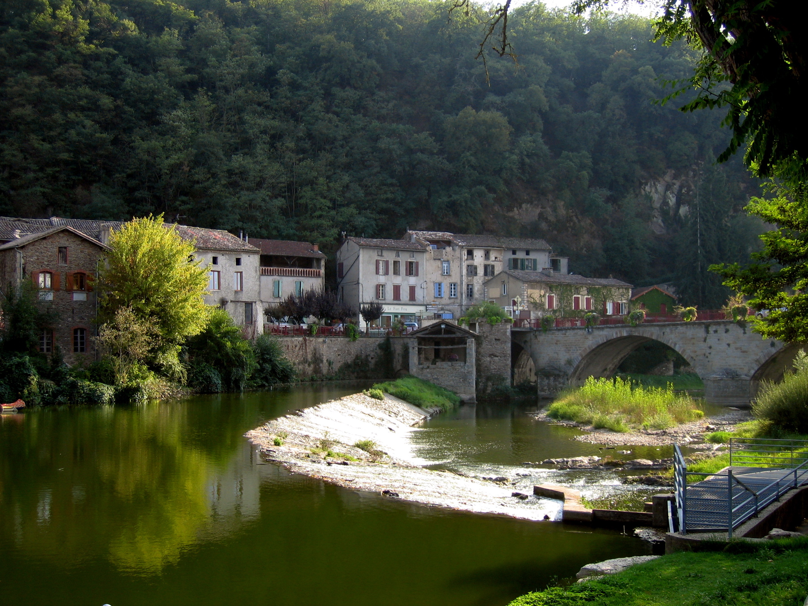
This Training Course takes place in Laguépie, a small village in the region Midi-Pyrénées, 100 km North-East of Toulouse, in the South-West of France. We will work and live in a hosting centre located some hundred meters from the train station, on the nice shore of the Aveyron river. Participants will be accommodated in rooms of 4 people (individual beds with one sheet and pillow.).

Everyone will be involved in daily collective life (cooking, cleaning...). Meals will be prepared everyday with fresh and local products by a team of local volunteers and a cook. All participants will be asked to help in the housework to keep the place tidy, as there is no “cleaning staff”.

Beside main activities, participants will have the opportunity to swim in the river, to hike on surrounding trails, to share about their culture, and visit a local place of their choice.

WHAT TO BRING FOR THE Training Course
- Sleeping bag and towel
- comfortable « sport » clothes and shoes for physical exercises inside and outside
- Swimming suit if you like to swim in the river
- Sun and rain protection clothes

Please bring a personal object that has meaning for you
(this will help us for presentation tool)

It would be nice if you also take anything you would like to share with the participants of the other countries about your own culture: costumes , music, pictures, food,games...

INSURANCE
As a participant in our project, you will be covered by our insurance in case you have an accident during this week in Laguépie.
InformaGiovani participants will also have insurance for health, travel and third parts liability.

HOW TO PARTICIPATE ?
For each participant, please fill up the following documents :
- Annexe 1 : Application form
- Annexe 2 : Image authorization

All these documents should be sent before August 15th 2016,
to InformaGiovani – at info@informa-giovani.org

FINANCIAL CONDITIONS
Board and lodging provided by the host organization.
Participation fee is 30 Euro.
If you are not yet InformaGiovani member, you must pay 30 Euro more.
Travel costs are covered up to 100%, up to 275 Euro
If you are accepted, you must pay the participation fee (and the membership fee) by the 19th of August.

MORE INFO ???
If you have any doubts or need more information about the Training Course please contact
Associazione InformaGiovani: info@informa-giovani.net – Tel. 338.1728439 – 393.9629434

