EURES – Vacancy form
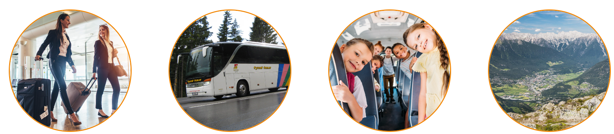

Description of Company
Tyrol Tour - Your bus company in Tyrol
is a bus company. The services range from bus hire for a hotel transfer or a city tour to a European tour lasting several weeks, the provision of city guides, tour guides and interpreters, to advice on suitable travel routes. We also organise one-day excursions and multi-day trips, trips for senior citizens, musical and festival trips (e.g. Vienna, Mörbisch, Bregenz, Verona) and, in winter, ski safaris to the most beautiful ski regions in Tyrol.

Job title  Job in PES in Austria  ADG NR 15470460 | BUSDRIVER m/f/d - Fulpmes in Stubaital or Ehrwald in Tyrol  Information about the region: Fulpmes – Wikipedia  and Stubaital, Tirol | Offizielle Website Tourismusverband Stubai Tirol - Stubaital Tirol
Job description | FIELD OF ACTIVITY:  - Domestic transport and passenger transport  - for our regular service in the Stubaital in Tyrol  - annual position  - full time with immediate effect
Skills:  Education, work experience, language, certificate etc. | REQUIREMENTS:  - Professional experience in public transport is an advantage  - Knowledge in handling ticket printers desirable  - Possession of a driver's licence is an advantage  - Class D driving licence  - If possible, knowledge of German appropriate to the position  - Good manners  - Sense of responsibility  - Reliability  - punctuality
Working hours and place of work | WORKING TIME: regular working hours: 3,4 or 5 working days / week possible  Fulpmes in the Stubaital in Tyrol  ACCOMMODATION IN Stubaital POSSIBLE: you need your own car to get to your workplace  Information about the region: Fulpmes – Wikipedia  and Stubaital, Tirol | Offizielle Website Tourismusverband Stubai Tirol - Stubaital Tirol
Start date (and, if necessary, End date) | 1. October 2023
Salary | The minimum salary including overpayment for the position of bus driver  is EUR 3002,96 gross per month on a full-time basis.
Other information | Overpayment possible if the skills are met by the worker (depending on education and work experience and is always negotiable with the employer)  According to the Austrian labor market law, 13th and 14th salary are aliquoted  ACCOMMODATION IN Stubaital POSSIBLE: you need your own car to get to your workplace  Benefits and other information:  You must have a work permit or free access to the Austrian labor market.  If you are employed all year round, you are entitled to 25 working days of vacation.  You acquire 2.08 vacation days per month. So with 5 months of work, about 10-12 days off.  High appreciation of the employees.  Health, pension, social and unemployment insurance from the 1st working day.  Regulated working hours and days off. Exact time recording.  A working atmosphere characterized by respect and mutual support.  Personal development and individual advancement of personal strengths.  Living and working in Austria:https://www.migration.gv.at/en/living-and-working-in-austria/  https://www.ams.at/arbeitsuchende/arbeiten-in-oesterreich-und-der-eu/laender-portraits  https://eures.ec.europa.eu/living-and-working/living-and-working-conditions/living-and-working-conditions-austria_de

Application
Last day for application | Untill the end of september 2023
How to apply? | Please send your CV to Mrs. Helga Steinberger – EURES Adviser Tyrol / eures.tirol@ams.at  And in cc to Maria Megna EURES adviser Regione Lombardia
Contact person/ telephone number | Mrs. Helga Steinberger – EURES Adviser Tyrol / eures.tirol@ams.at  Mobil: 0043 (0) 664 7876 8397

