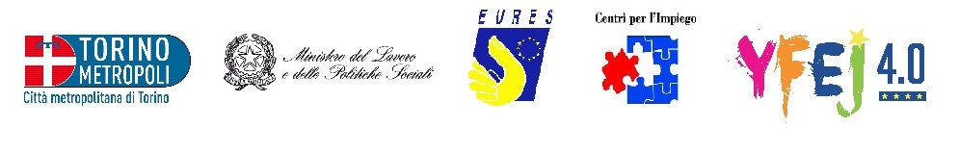
100 Nurses for the UK
National Health Service (NHS)Recruitment
Join the NHS Directly- Not Through an Agency
This offer is part of YFEJ Project

Description:
The English NHS is currently looking for nurses to cover clinical areas/wards such as: Acute Medicine Trauma and Orthopaedics, General Surgery, Renal Services (including acute dialysis), Theatres (adult and paediatric), Paediatric Oncology and Haematology, Intensive Critical Care (adult and paediatrics accident and emergency neonatal conditions).

Location:
The nursing posts available are all in variety of clinical settings in hospitals in the West Midlands area of England. This is a metropolitan county in central England which incorporates the City of Birmingham and Wolverhampton, as well as Dudley and the Black Country, Burton, Staffordshire and Worcestershire. The region is geographically diverse , from busy urban cities to a more rural relaxed lifestyle. There may be other destinations available

Requirements
Candidates must be:
- registered nurses who have already completed their preceptorship
- new graduates
Level of English language: B1

Conditions
Permanent full time contract. The salary scale is 21,478-27,901£ pro rata.
Paid UK Accommodation for the first month
Paid Flights to the UK
Support with NMC registration
6 Weeks Induction Program
Opportunities to Specialise in a Number of Fields

How to apply
Please send your CV and a motivation letter, both in English, quoting “Nurse for the UK” in the object of the mail, to: eures@cittametropolitana.torino.it
The selected candidates will be invited for an interview in Turin with the NHS at the end of November

Deadline
15/11/2015

