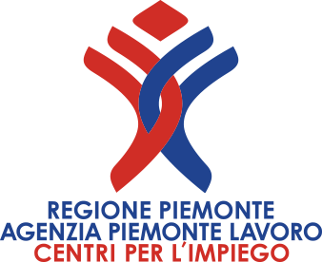
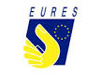

Sofia - Bulgaria
Multinational Company is looking for

5 TECHNICAL SUPPORT SPECIALIST (YFEJ/REACTIVATE)
ITALIAN MOTHER TONGUE AND ENGLISH LEVEL B2/C
Deliver a high level of custode service by:
Italian mother tongue, English level B2/C
Answer telephone calls and deal with them promptly, efficiently and with empathy to ensure a positive experience for our customer
Validate custode service entitlements
Provide Hardware and Software telephone support with a goal to meet set targets consistently
Assume responsabilità and ownership for all relevant custode queries
Escalate calls that cannot be resolves locally, as appropriate
Obtain accurate custode details and amend call-handling system when applicable
Positively manage internal relationships
Contribute positively towards the achievement of performance targets in all aspect of the team’s activities.
Use and improve knowledge bases through feedback
Ensure through team work that alla service Agreements (SLAs) are met consistently
Conditions:
Permanent contract, 40 h. per week; salary gross EUR min.900 to max 1.000
Travel assistance, Accomodation assistances
How to apply: Send your complete and updated Curriculum in English to:
eures@agenziapiemontelavoro.it For information about YFEJ/REACTIVATE: eures@agenziapiemontelavoro.it
Application deadline: 21 JANUARY 2020
SELECTION DAY IN TURIN: 26 JANUARY 2020

